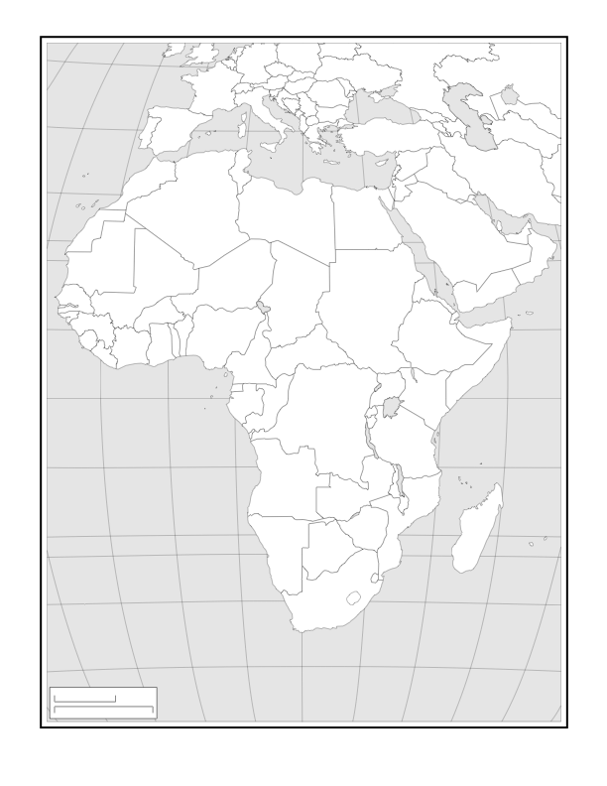

AFRICA MAP TEST 50 POINTS



6

2

12

21

A

D

C

17

16

4

3

B

5

1

19

10

8

7

9

11

18

13

14

15

200

